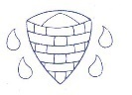
Which, Witch or Wich?
THE TUDORS
Can
How do physical geographical features effect human settlement and geography?  Many of the main cities and towns in the world are built around rivers, for example London being built on the Thames.  The water from the river provides rich soil for farming. This means the town will never go hungry and can trade any crops with other towns.  The river provides transportation so as well as being able to travel, the people can trade their goods easily with other towns.  Salt was an important resources which Nantwich could trade with other towns in England.  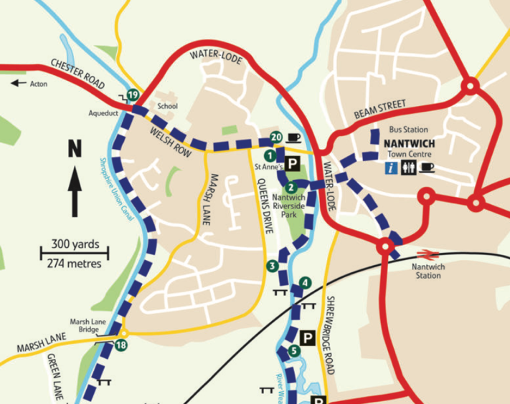 |  | Can I analyse changes in landuse of buildings over time?  Using your skills of observation and historical knowledge, while carrying out geography fieldwork, in Nantwich, you will be able to use a map of the locality to deduce which buildings were original Tudor buildings and which are more recent. For the Tudor buildings, which have had a change in use over time? Think about why these changes may have occurred, could it be: changes in methods of transport; changes in the needs of the locality or the increase in the use of the internet for shopping?  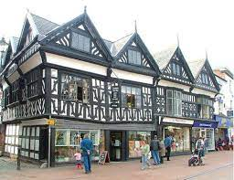 |  | How do we locate important/key places on a map?  - First, find the four-figure grid reference but leave a space after the first two digits.  - Estimate or measure how many tenths across the grid square your symbol lies. Write this number after the first two digits.  - Next, estimate how many tenths up the grid square your symbol lies. Write this number after the last two digits.  - You now have a six figure grid reference. In this instance, the tourist information office is located at 476334.  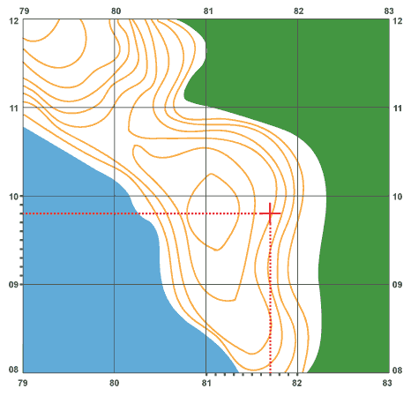
Industry – economic activity concerned with processing raw materials or manufacturing goods in factories. | Landuse – the purpose of different pieces of land. Thinking about what the land is used for (woodland / farmland / settlements / housing / tourism). |  | Commercial – the activity of buying or selling on a large scale, for example, in a shop. |  | Decline – For something that is good or popular to become smaller or fewer or decrease.
Year 6 – Autumn Term Themes: Local, Pride
Year 6 – Autumn Term Themes: Local, Pride

