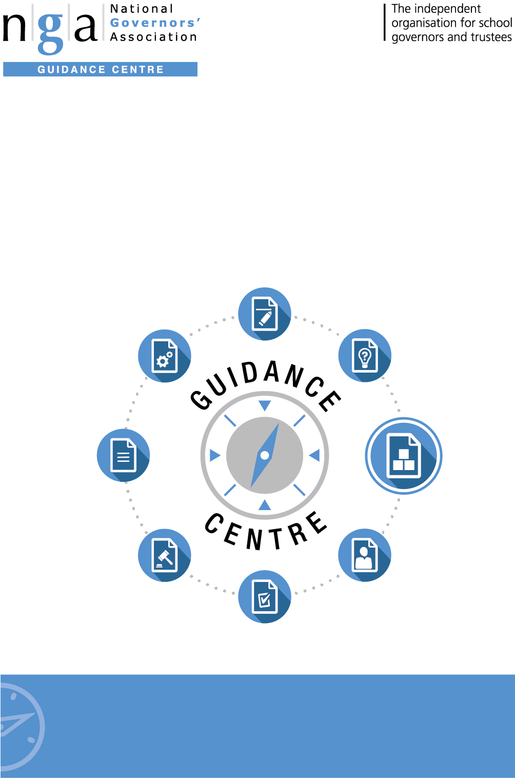

Parent governor elections – Maintained schools: Qualifications and disqualifications to serve as a school governor
Policies and procedures
Need advice?
For advice on any issue, Gold members have access to GOLDline legal advice
9 –5pm weekdays. Find out more T: 0121 237 3782 www.nga.org.uk/goldline

Need advice?
For advice on any issue, Gold members have access to GOLDline legal advice
9 –5pm weekdays. Find out more T: 0121 237 3782 www.nga.org.uk/goldline

National Governors’ Association
The National Governors’ Association (NGA) is an independent charity representing and supporting governors, trustees and clerks in maintained schools and academies in England. The NGA’s goal is to improve the well-being of children and young people by increasing the effectiveness of governing boards and promoting high standards. It does this by providing information, guidance, research, advice and training. It also works closely with, and lobbies, UK government and educational bodies, and is the leading campaigning national membership organisation for school governors and trustees.

The NGA online Guidance Centre is the information hub for governors. It supports you in your role as a governor, giving you access to up to date guidance and advice covering all aspects of school governance, including finance; staffing; Ofsted; curriculum; special educational needs; legislation and school improvement.

Practical governance resources include sample documents; templates; checklists; information summaries; insights; case studies and much more.
To join NGA and receive regular updates, contact:
T: 0121 237 3780 | E: membership@nga.org.uk | www.nga.org.uk

Annex E – Maintained schools: Qualifications and disqualifications to serve as a school governor

A governor must be aged 18 or over at the time of his/her election or appointment and cannot hold more than one governorship at the same school.
A person is disqualified from election or appointment as a parent governor if s/he:
- is employed at the school for more than 500 hours in any 12 consecutive months;
- is an elected member of the Local Authority.
A person is disqualified from holding or continuing to hold office as a governor or associate member if he or she:
- is a registered pupil at the school;
- has failed to attend governing body meetings at the school without the consent of the governing body, for a continuous period of six months;
- has been disqualified for failing to attend governing body meetings at the school without the consent of the governing body, for a continuous period of six months whilst serving as a foundation, local authority, co-opted or partnership governor at the school in the last 12 months;
- has had his/her estate sequestrated and the sequestration has not been discharged, annulled or reduced;
- is subject to a bankruptcy restriction order, an interim bankruptcy restrictions order, a debt relief restrictions order or an interim debt relief restrictions order;
- is subject to:
  - a disqualification order or disqualification undertaking under the Company Directors Disqualification Act 1986
  - a disqualification order under the Companies Directors Disqualification (Northern Ireland) Order 2002
  - a disqualification undertaking accepted under the Company Directors Disqualification (Northern Ireland) Order 2002
  - an order made under section 429(2)(b) of the Insolvency Act 1986 (failure to pay under a county court administration order);
- has been removed from the office of charity trustee or trustee for a charity by an order made by the Charity Commission or Commissioners or High Court on the grounds of any misconduct or mismanagement in the administration of the charity for which he was responsible; or to which he was privy; or to which he contributed or he facilitated by his conduct; or
- has been removed, under section 34 of the Charities and Trustee Investment (Scotland) Act 2005, from being concerned in the management or control of any body;
- is included in the list of people considered by the Secretary of State as unsuitable to work with children (under section 1 of the Protection of Children Act 1999);
- is subject to a direction of the Secretary of State under section 142 of the Education Act 2002 (or any other disqualification, prohibition or restriction which takes effect as if contained in such a direction);
- is subject to a direction of the Secretary of State under section 128 of the Education and Skills Act 2008;
- is barred from regulated activity relating to children in accordance with section 3(2) of the Safeguarding Vulnerable Groups Act 2006;
- is disqualified from working with children under sections 28, 29, or 29A of the Criminal Justice and Court Services Act 2000;
- is disqualified from registration under Part 2 of the Children and Families (Wales) Measure 2010 for child minding or providing day care;
- is disqualified from registration under Part 3 of the Childcare Act 2006;
- has been convicted of any offence and received a sentence of imprisonment (whether suspended or not) for a period of not less than 3 months (without the option of a fine) in the 5 years before or since becoming a governor;
- has been convicted of any offence and received a prison sentence of two and a half years or more in the 20 years before becoming a governor;
- has been convicted of any offence at any time and received a prison sentence of 5 years or more;
- has been convicted of an offence and sentenced to a fine under section 547 of EA 1996 (nuisance or disturbance on school premises) or under section 85A of the Further and Higher Education Act 1992 (nuisance or disturbance on educational premise) during the 5 years prior to or since appointment or election as a governor;
- has refused a request by the clerk to the governing body to make an application under section 113B of the Police Act 1997 for a criminal records certificate.

